Eratosthenes Experiment 2016

School: Tacher:
Latitude:
Longitude:
Table measurements
Length of the statue
Length of the statue's shadow (first measurement)
Length of the statue's shadow (second measurement)
Length of the statue's shadow (third measurement)
Length of the statue's shadow (fourth measurement)
Length of the statue's shadow (fifth measurement)
Mean value of the length of the shadows
Length third party triangle
Distance between schools

Angle calculation: 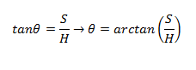
The value of the angle θ : ____________________________
The value of the angle φ :
Subtract the two corners. The resulting value corresponds to the angular distance between for two schools. Earth radius: R= 6.371 km
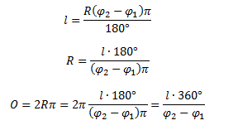
The volume of the Earth on the meridian:
The volume of the Earth around the equator 40 075 km
The volume of the Earth on the meridian 40 007,86 km

